Fin Cover Ansys Investigation

1. Set-up

Different fin covers were tested using ansys fluent density based solver. Domain was constructed such that it extended 300 mm behind the back edge of the fin, 200 mm in front of the fin, and 125 mm from the other edges. The bottom of the domain wall lines up with the bottom edge of the fin. First to higher order blending was used to attempt to damp out oscillations in the continuity residuals. Automatic refinement was used to refine high pressure gradient cells every 100 iterations. Solutions are converged when continuity residual reach 1 x 10-6.

Shapes tested:

* Bare Fin
* Current Airfoil
* Current Airfoil with some cut off the trailing edge
* Current Airfoil with most cut off the trailing edge
* Current Airfoil with almost all of trailing edge cut off
* Smaller Airfoil that does not cover the entire fin

1. Bare Fin Results

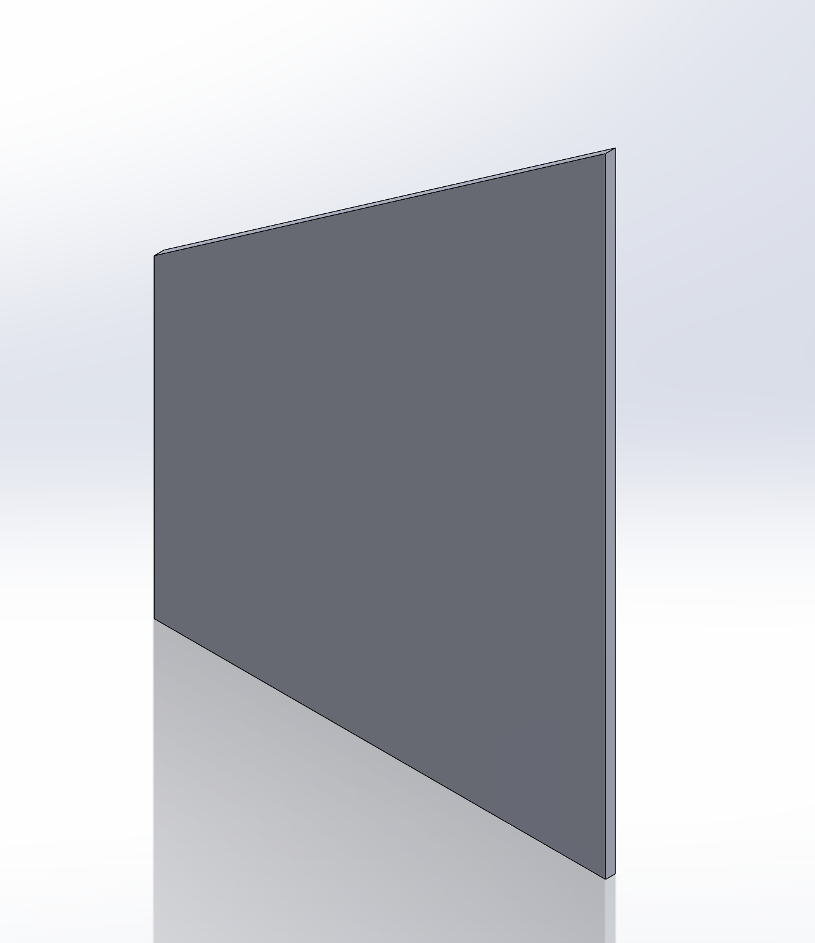

Geometry

Volume: 0 in3

Velocity Contour Plot

Drag Force: 5.8805059 N

1. Current Airfoil Results

Geometry

Volume: 7.41 in3

Velocity Contour Plot

Drag Force: 4.1975856 N

1. Current Airfoil Some Cut

Geometry

Volume: 7.08 in3

Residuals Plot

Velocity Contour Plot

Drag Force: 4.2432439 N

Even though this did not converge like the others, the result makes sense.

1. Current Airfoil Most Cut

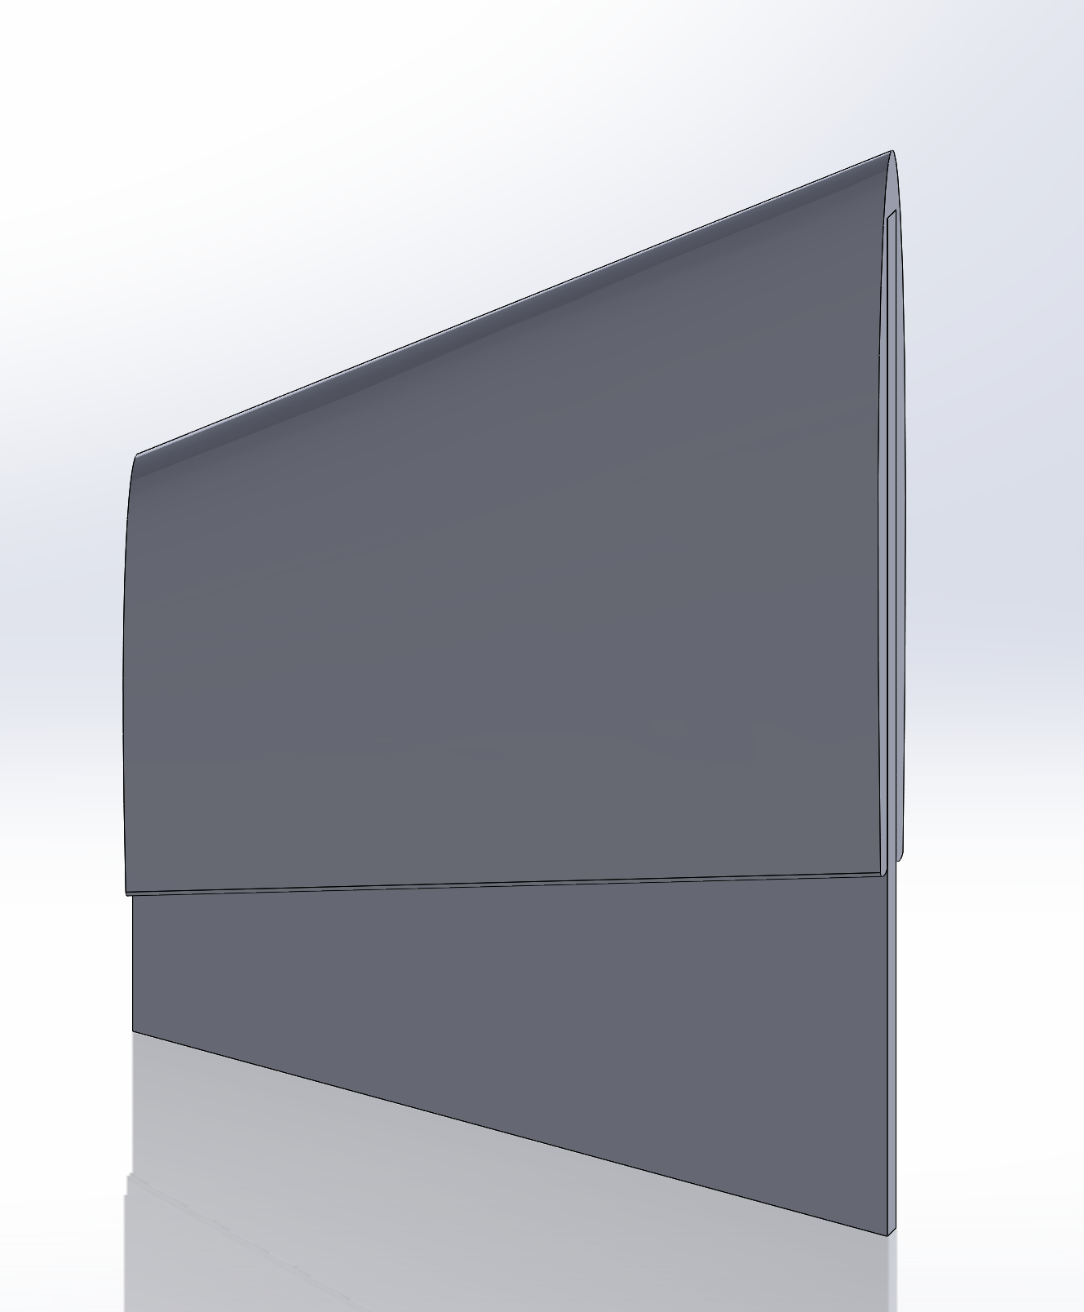

Geometry

Volume: 6.09 in3

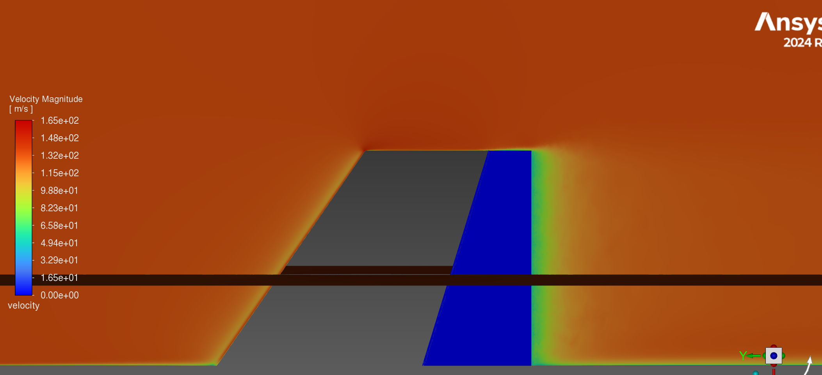

Velocity Contour Plot

Drag Force: 4.8751383 N

1. Current Airfoil All Cut

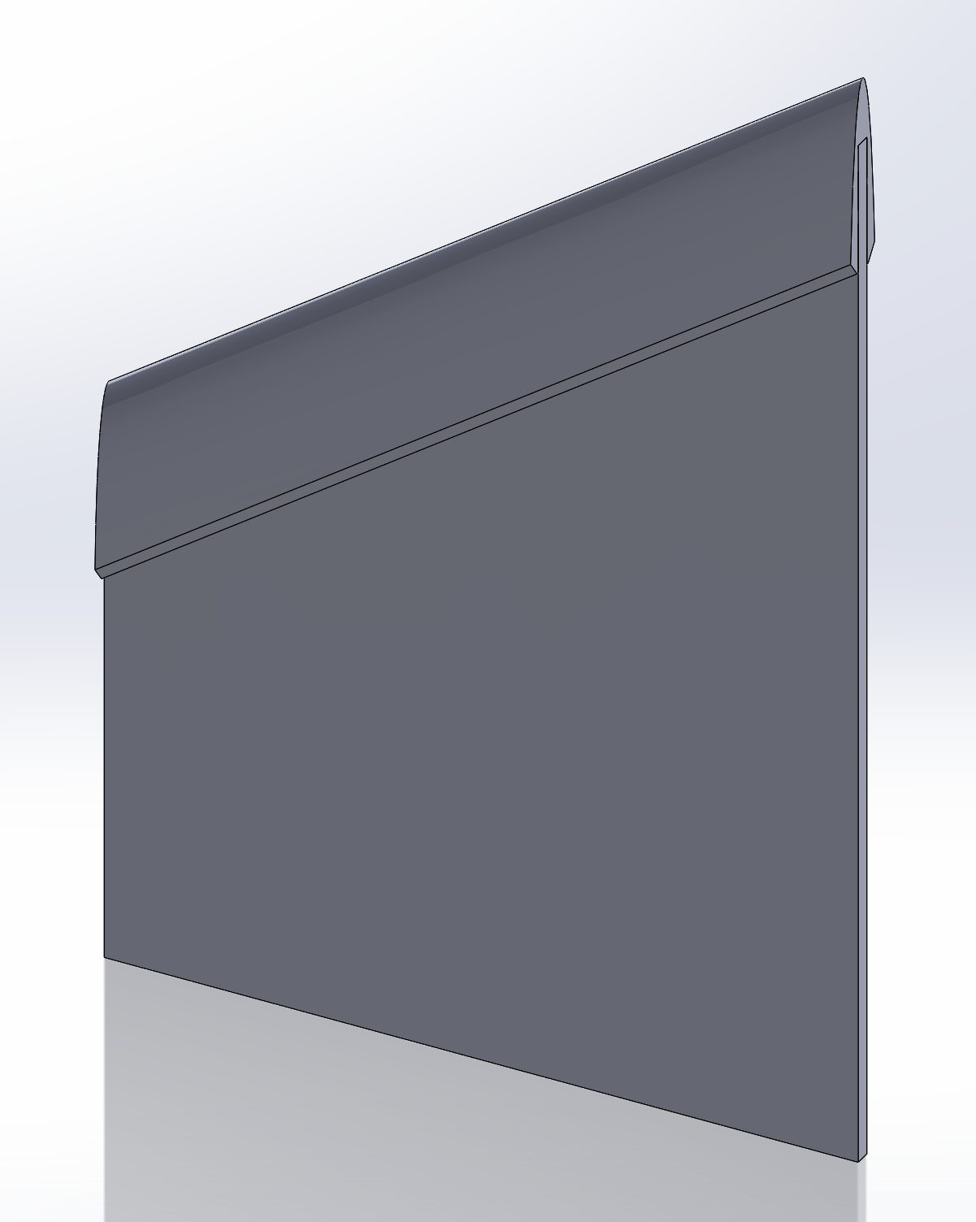

Geometry

Volume: 1.64 in3

Velocity Contour Plot

Drag Force: 6.0303478 N

1. Smaller Airfoil

Geometry

Volume: 4.81 in3

Velocity Contour Plot

Drag Force: 4.2829938 N

1. Compiled Results

|  |  |  |
| --- | --- | --- |
| Shape | Drag Force (N) | Additional Volume (in3) |
| No Airfoil | 5.8805059 | 0.00 |
| Current Airfoil | 4.1975856 | 7.41 |
| Current Airfoil with Some Cut | 4.2432439 | 7.08 |
| Current Airfoil with Most Cut | 4.8751383 | 6.09 |
| Current Airfoil with All Cut | 6.0303478 | 1.64 |
| Smaller Airfoil | 4.2829938 | 4.81 |

Notes: Results potentially highly dependent on value used for first-to-higher-order blending. Changing from 90% second-order to 80% second-order changed drag on certain fin by 0.5 N. All results are from 90% blending, so should be comparable.